PERSONALITY PREDICTION SYSTEM THROUGH CV ANALYSIS

- Modules:

Our system mainly comprises of two modules:
Admin
User/candidate

Admin:
Login: Admin need to login with its valid credentials to access the below modules.
Add Job Details: Admin or any authorized person can add the requirement or job details on behalf of company. System allows admin to job details such as position, experience, salary, etc.
Preferred CV’s: Admin will add some CV’s which are preferable and will be used to shortlist the scanned CV’s.
Scan CV: Admin can scan CV’s received from candidates which will undergo the process of shortlisting the CV’s. Based on the company requirement, the candidate who have submitted their CV to admin or any authorized person, will be uploaded by the admin into the system.
Shortlisted CV’s: Here, all the shortlisted CV’s of candidates will be displayed. The shortlisting of CV’s is performed by system itself.
View Candidates: Can view all the registered candidates with its details.
View Result: Can view the results of individual candidate, which can be easy to admin or concern person to select a desired candidate.

Candidate:
Registration: To access the below given modules, candidate must fill up registration form and create login credentials in order to get the access to the system. While registration process, candidate need to upload their CV.
Login: Candidate need to enter valid credentials to access the below given modules.
Menu Page: After login the candidate goes to menu page, in that page include three buttons as a profile summary, view all jobs and applied applications.
Profile Summary: In that page we can update all the candidate essential information.
View All Jobs: In that page Candidate can view all the jobs that can admin updated in database.
Applied Applications: in that page candidate can apply one and more than one job by clicking apply button. If candidate dose not want that job then they click on apply to withdrawn button.
View Results: Once the test is completed by the candidate, the results will be displayed in a graphical representation.

- Algorithm:

Designed an algorithm for shortlisting the candidate’s CV to ensure candidate meets the required criteria.
Depiction:
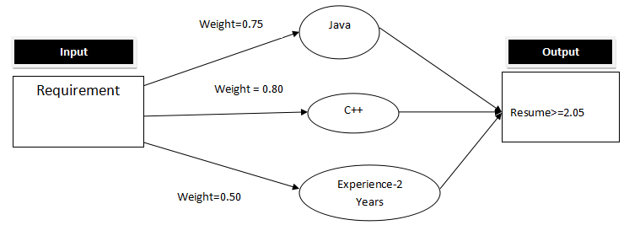

- Workflow of system:

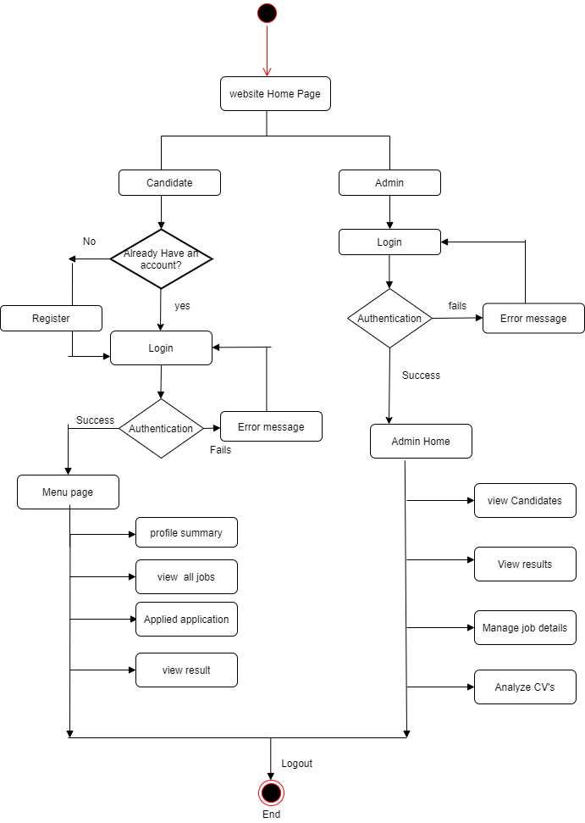

- Function Requirements:

1. Candidate/Admin can access the site registering the provided credentials.
2. Candidate redirected to login page already registered and can take the rest for the corresponding job application.
3. Admin can do the appropriate functionalities by login in the portal.
4. After candidate login they can be redirect to menu page.
5. Menu Page include the Profile Summary, View all jobs and Applied applications.
6. In View jobs can include all the job list that can be present on admin database.
7. The candidate can apply one and more than one job also after applied for the job the candidate shows the applied job at applied application page.
8. Admin must be able to update the job details according to company requirements
9. Resumes should be in readable format
10. System should be able to read resume and extract required data
11. Admin should be able to store attributes values from extracted data
12. Admin have access to run algorithm for shortlisting.
13. Admin should be able to generate results on candidate dashboard
14. Candidates should receive copy of result to their end.

5) Use Case Diagram
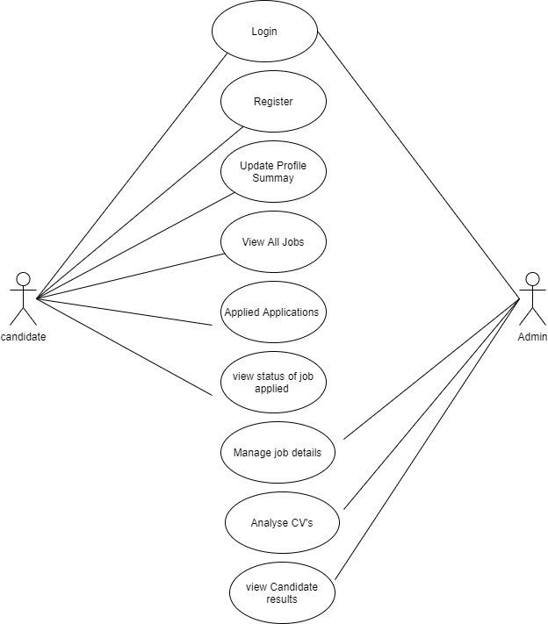

6) Data Flow Diagram
a) Zero Level DFT
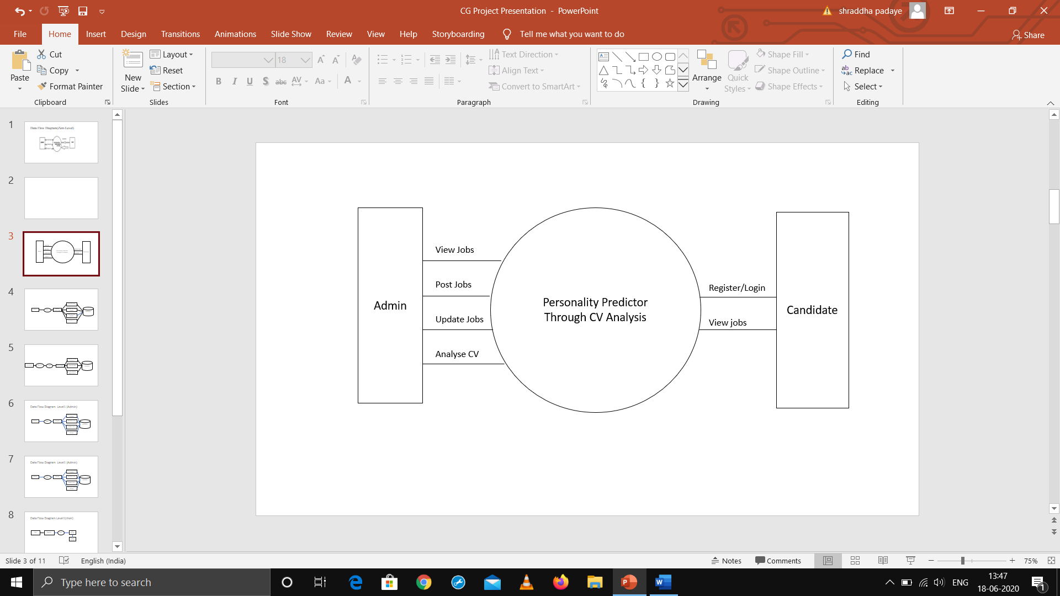
- One Level DFT For Admin

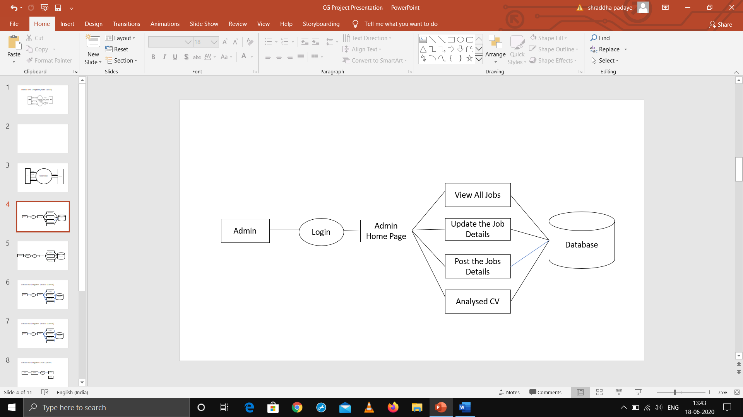
- One Level DFT For Candidate

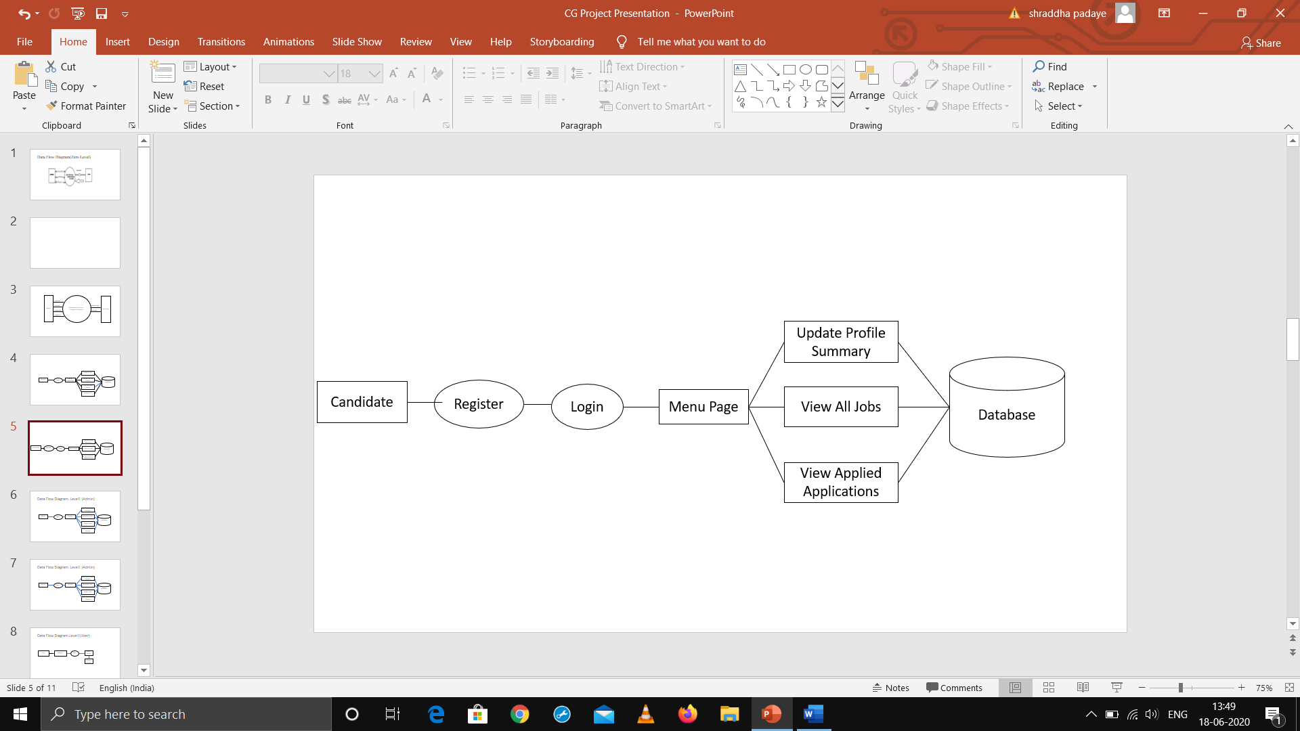

7.Wireframes

- Candidate Wireframes

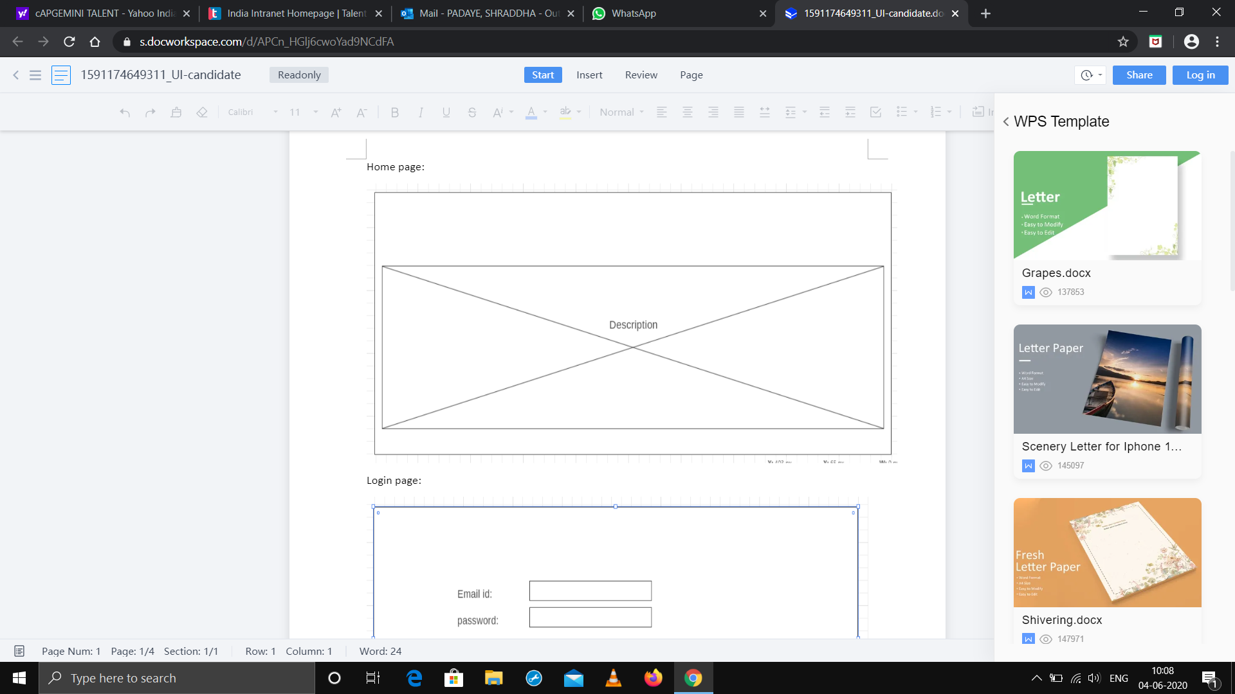

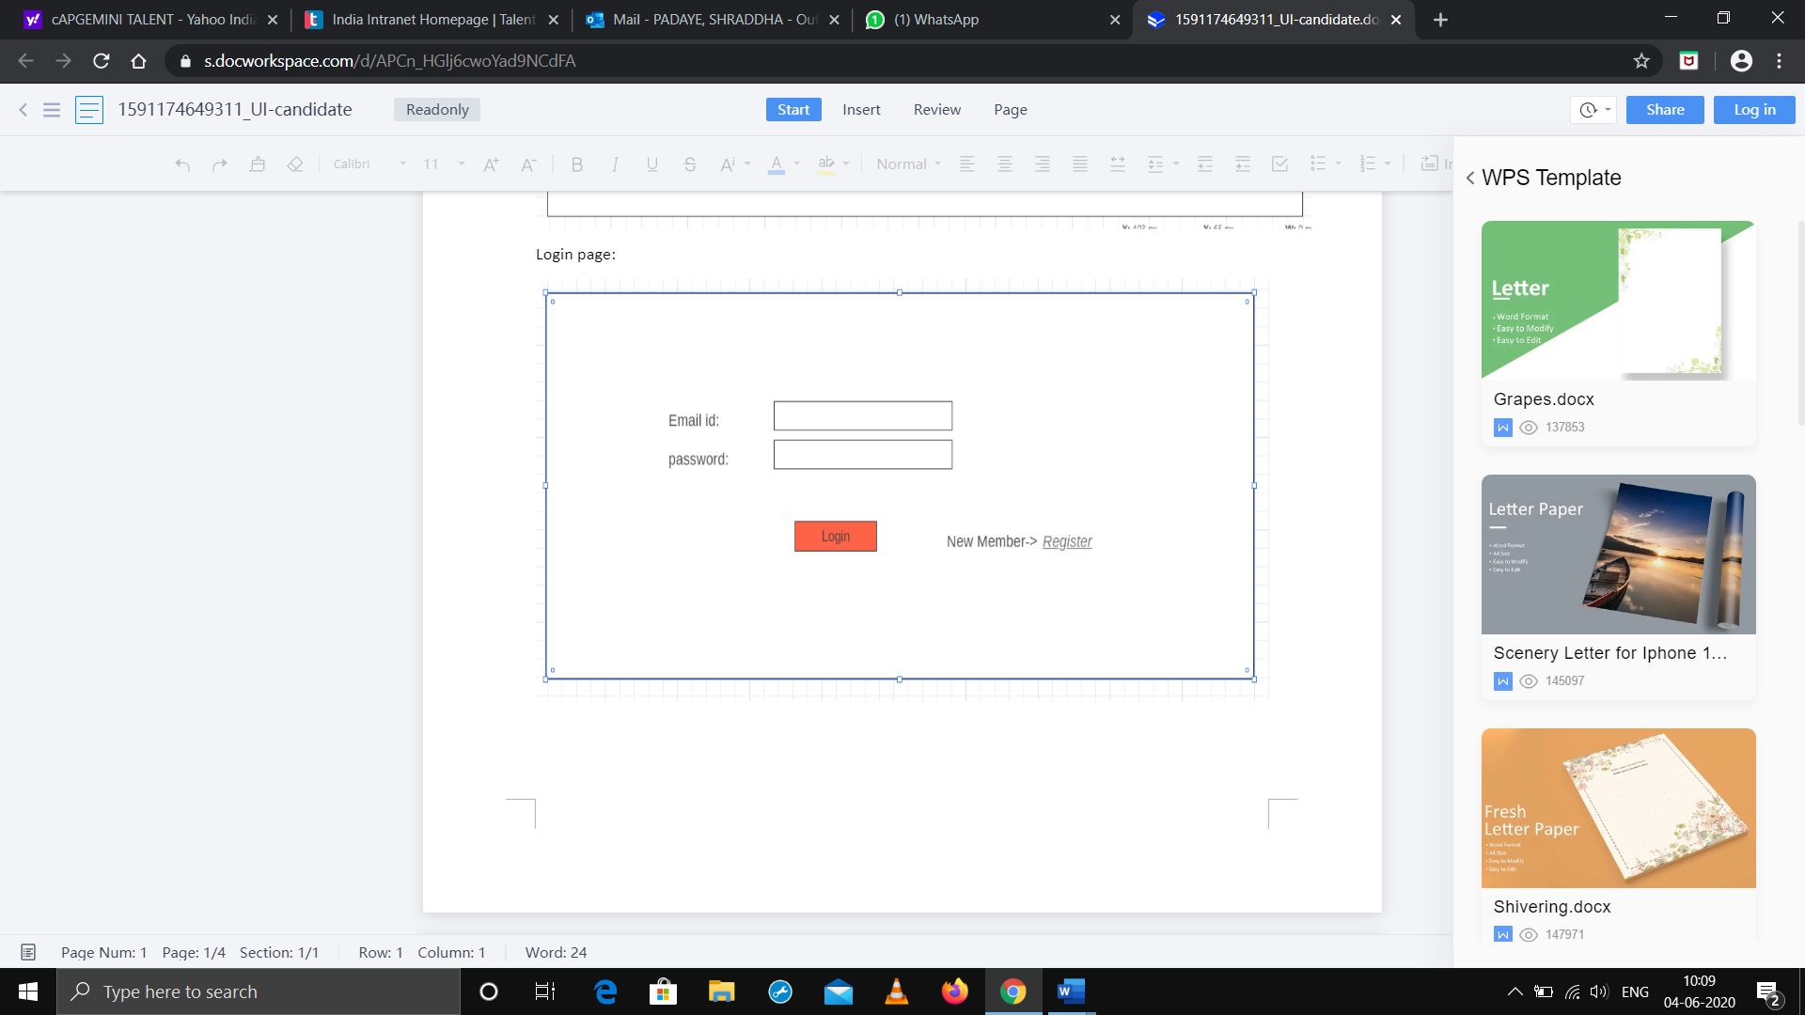

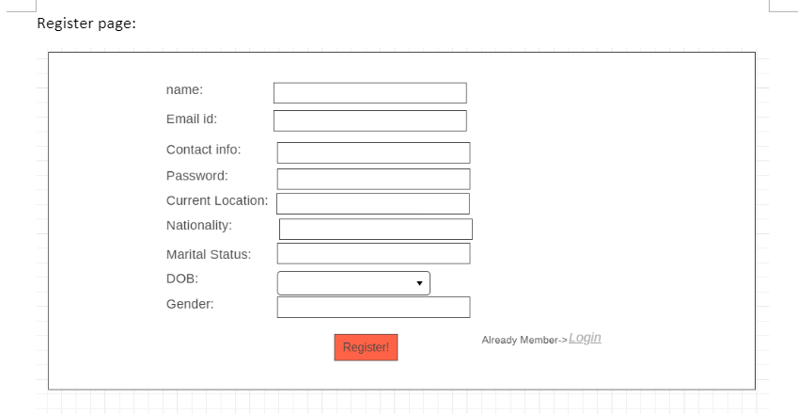
After login page the redirected to menu page
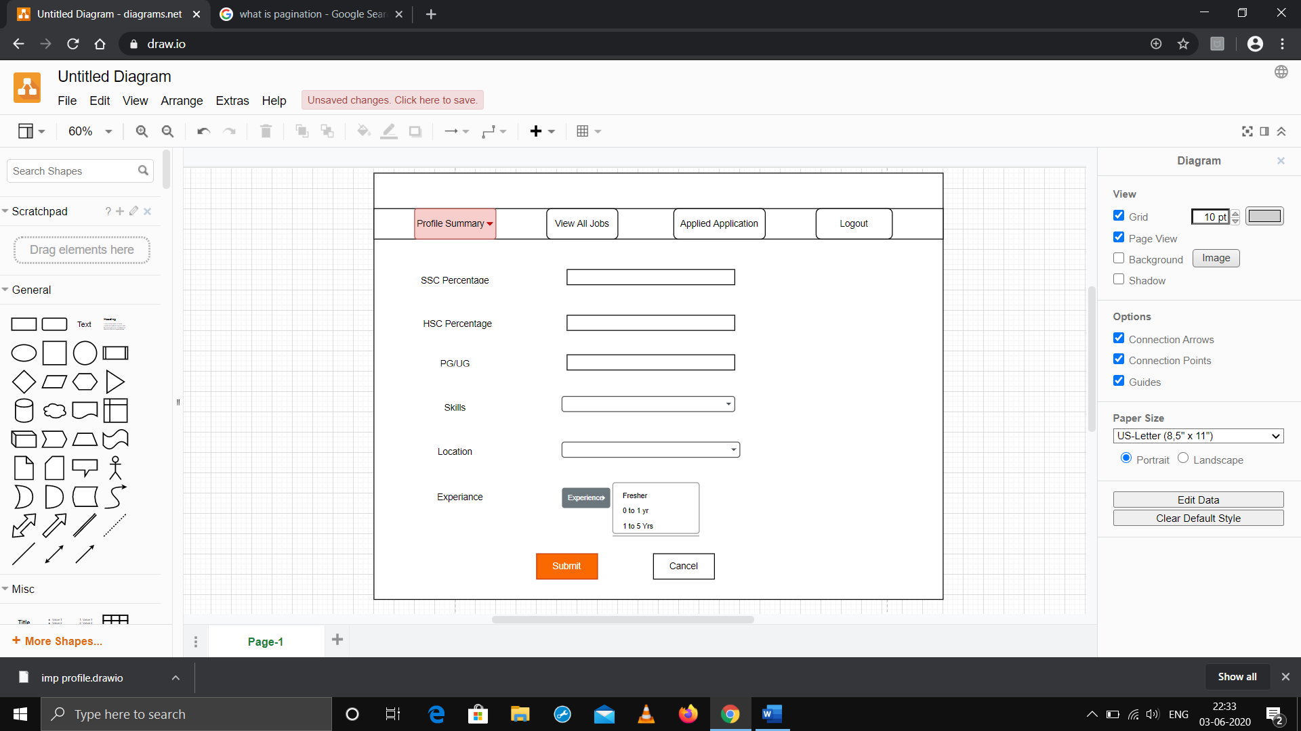

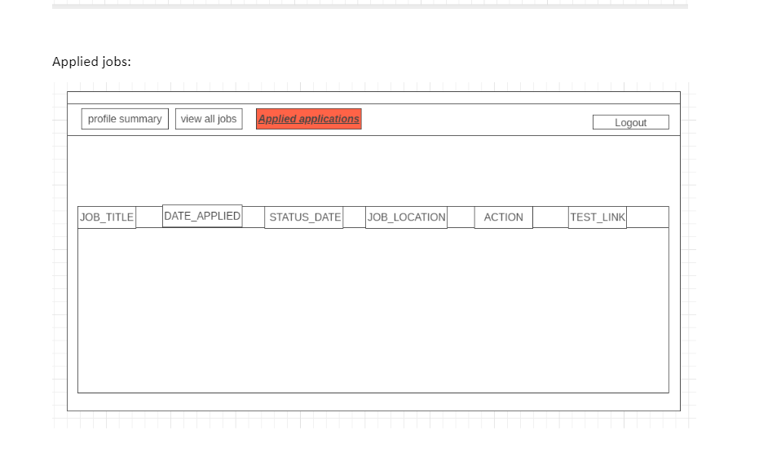

- Admin Wireframes

Admin Page Flow:

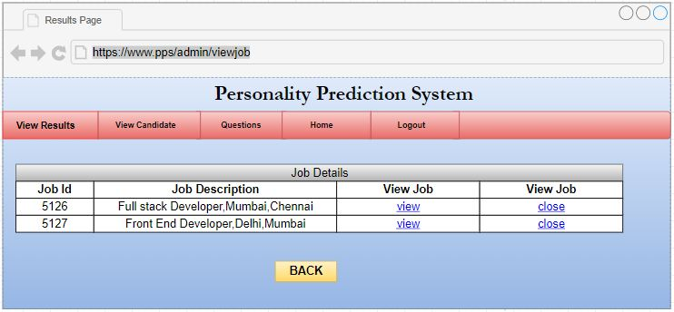

Adding a job: 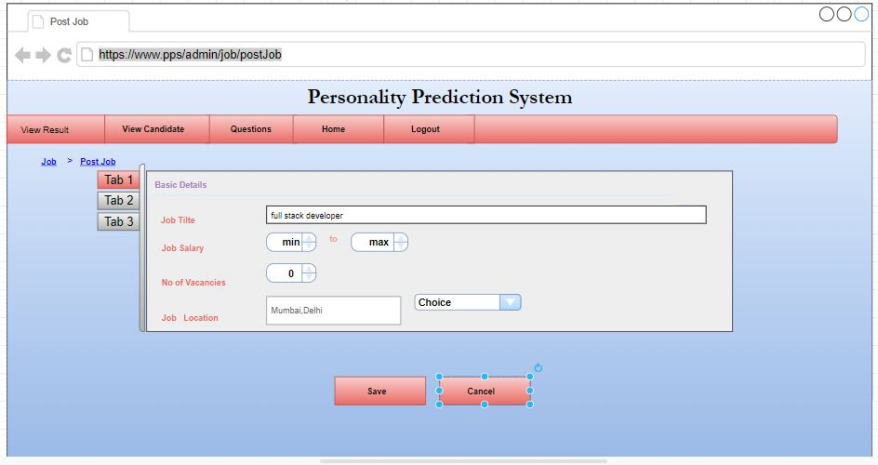
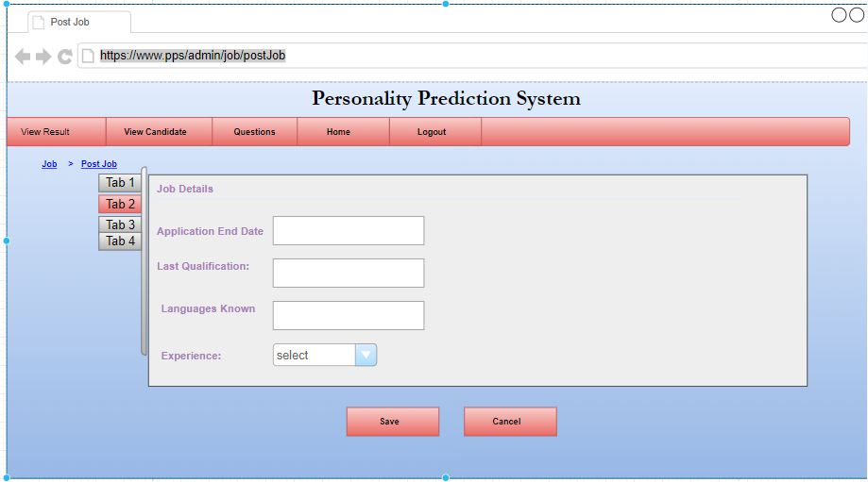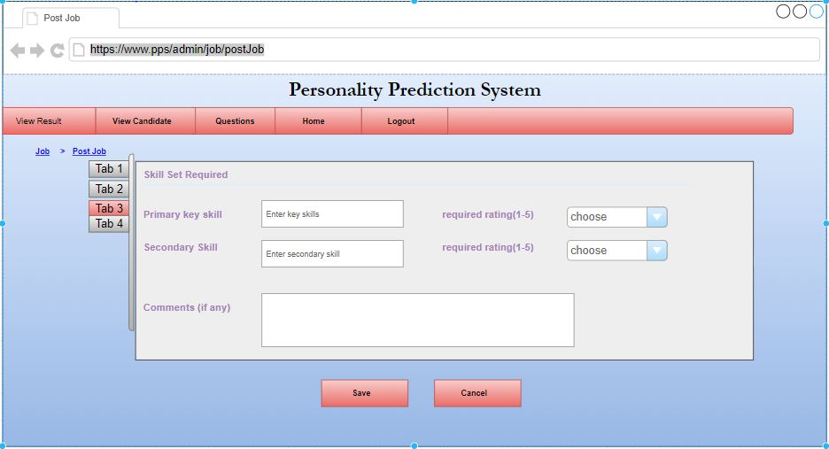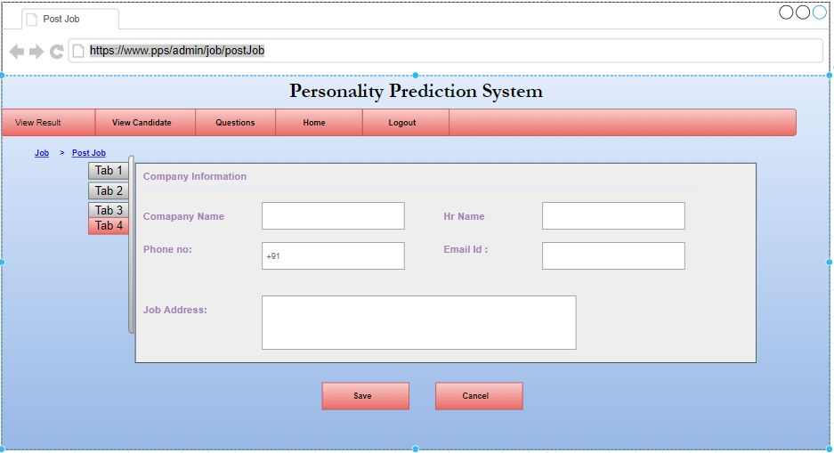

Analyze CVs:
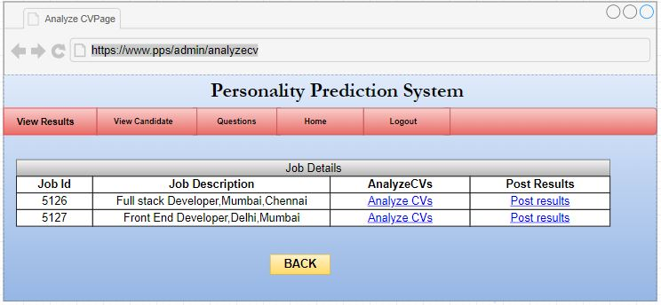

Update Job Description
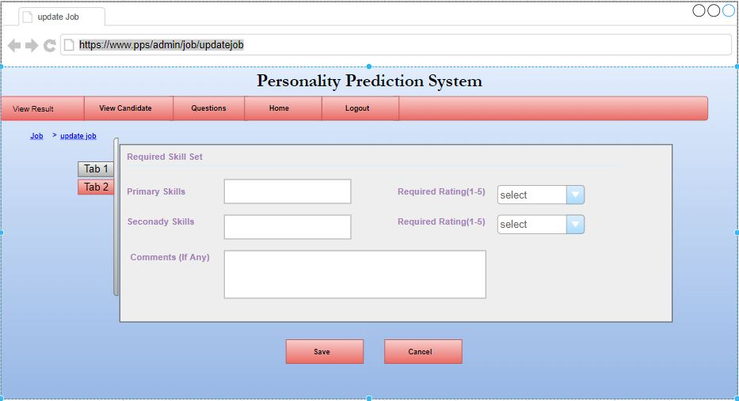
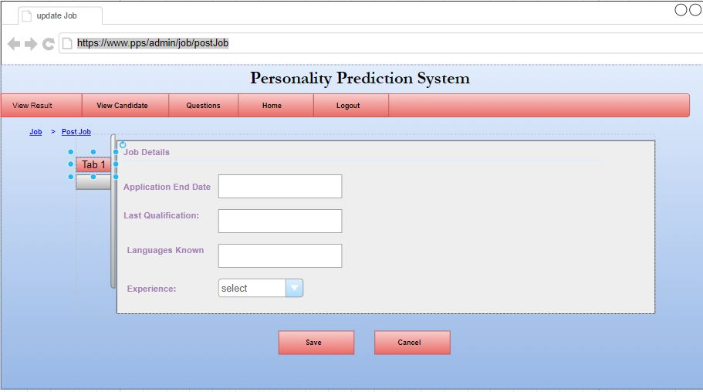

View Candidate: 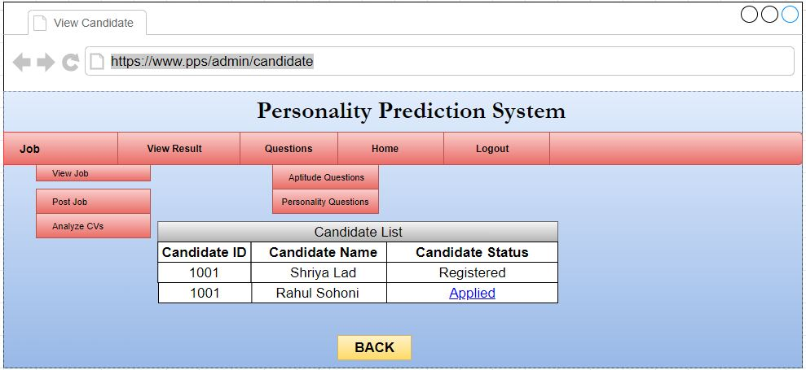
View results:
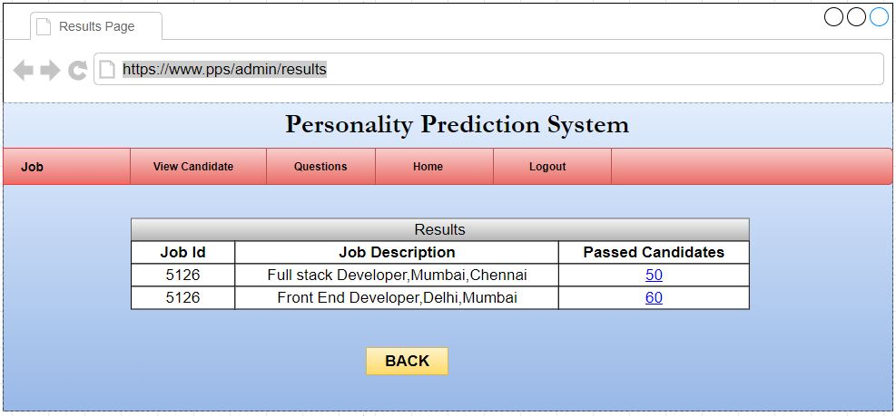

8) Sequence Diagram
Architecture Followed:

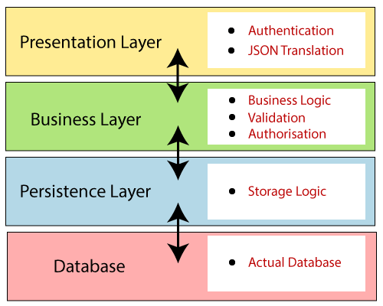
Instead of developing whole application in one unit divided in to seperate layers for more feasible, testability etc.
Following:
Presentation Layer: The presentation layer handles the HTTP requests, translates the JSON parameter to object, and authenticates the request and transfer it to the business layer. In short, it consists of views i.e., frontend part.
Business Layer: The business layer handles all the business logic. It consists of service classes and uses services provided by data access layers. It also performs authorization and validation.
Persistence Layer: The persistence layer contains all the storage logic and translates business objects from and to database rows.
Database Layer: In the database layer, CRUD (create, retrieve, update, delete) operations are performed.
Sequence Diagrams of prediction System through CV analysis:
Sequence Diagram of Registration System:

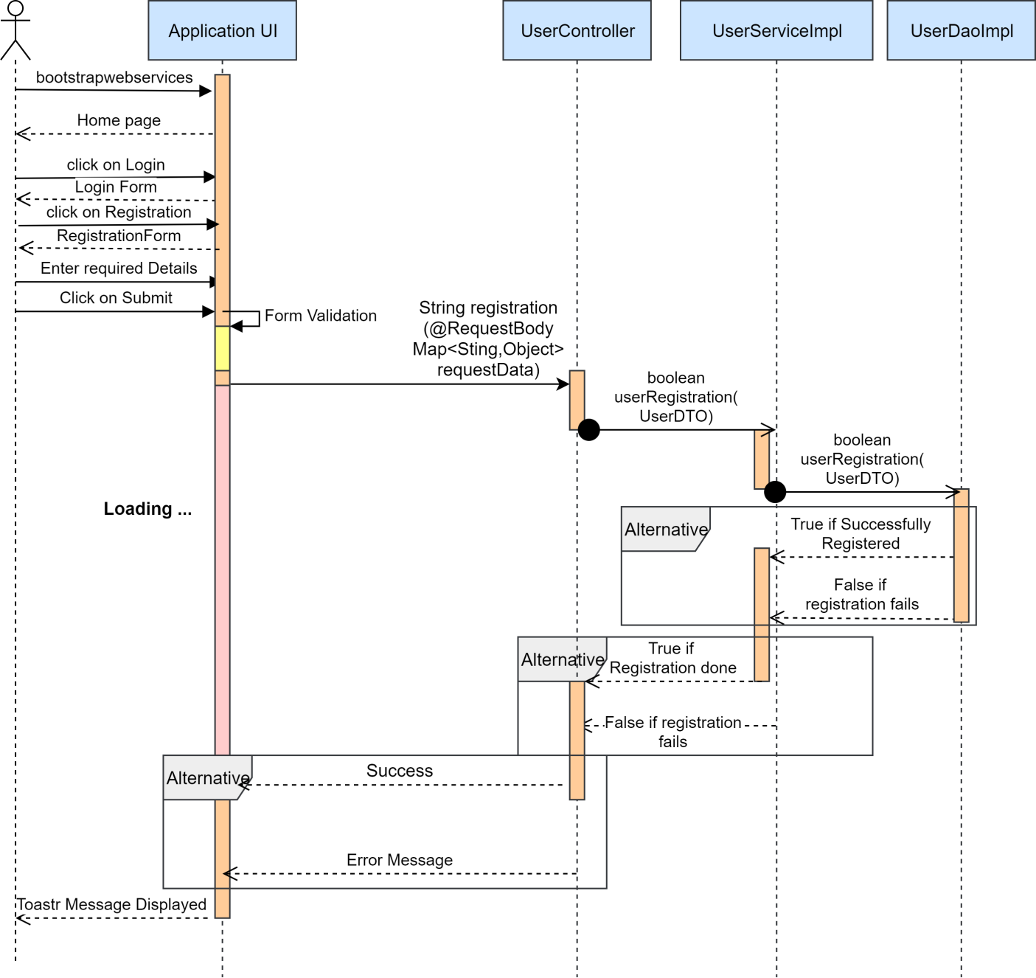

Sequence Diagram of Login system:

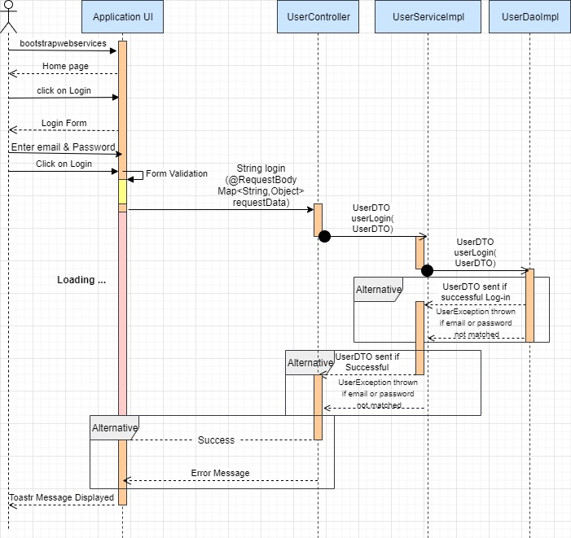

Sequence Diagram of Logout:
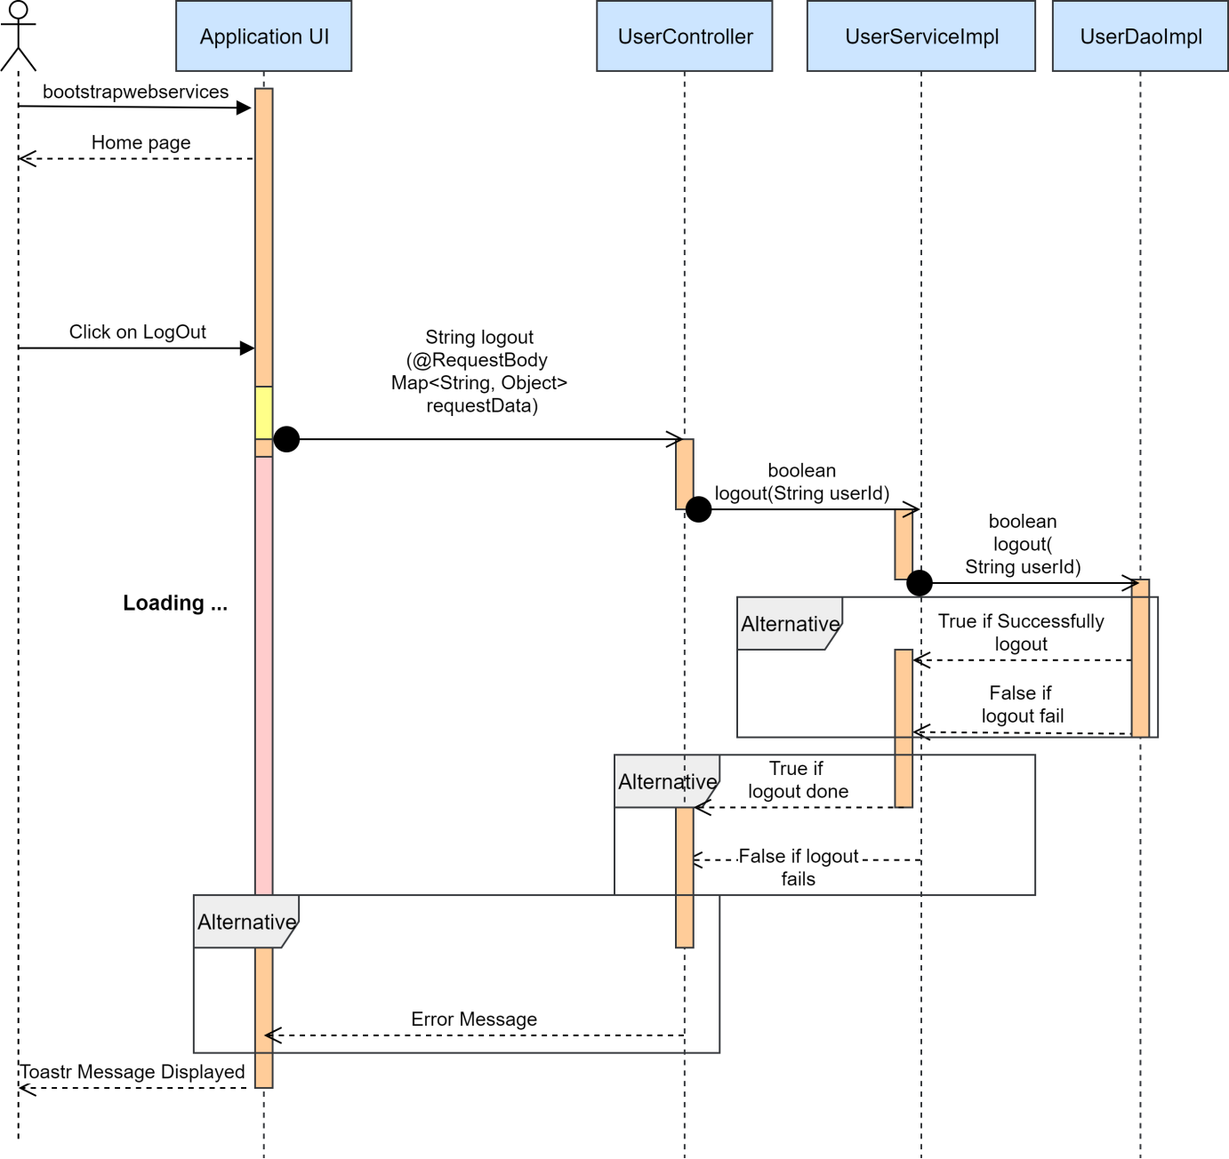

Sequence diagram of candidate updating CV information:

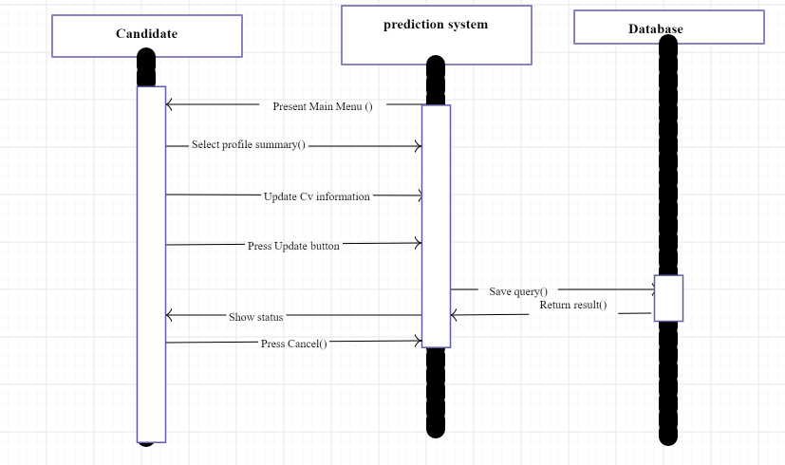

Sequence diagram for candidate:(job exploration)

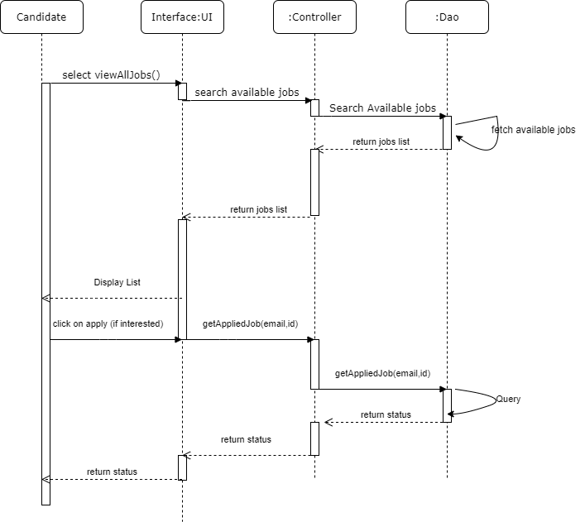

Sequence diagram for the candidate:(to view all applied applications)
